| D:\PENGAJARAN ITATS\KEGIATAN AKADEMIK INSTITUSI\ITATS_copy copy_2.png |  | | | |  |
| --- | --- | --- | --- | --- | --- |
| **JURNAL IPTEK**  **MEDIA KOMUNIKASI TEKNOLOGI** | | | |
| homepage URL : ejurnal.itats.ac.id/index.php/iptek | | | |
|  | | | |
|  | |  |  |  | | |
| **Templates and Styles of ITATS Journal Articles Science and Technology Communication Technology – Font13** | | | | | |
| *First Author1, Second Author2, and Third Author3 – font11* | | | | | |
| *Author Affiliation1, Author Affiliation2, Author Affiliation3 – font11* | | | | | |
| **ARTICLE INFORMATION** | |  | ***ABSTRACT*** | | |
| Journal of Science and Technology – Volume xx  Number xx, May 2018  Page:  1 – 10  Date of issue :  May 20, 2018  DOI:  10.31284/j.iptek.2017.v21i2.91 | |  | In the beginning, there are two abstracts, namely English and Indonesian. The abstract contains the entire summary that is able to represent the essential research that has been carried out and has conformity with the contents of the article from the introduction to the conclusion. Abstract writing consists of no more than 200 words, one paragraph, time newroman font 10, space 1 and for ABSTRACT it is written in italics. In the abstract it is not allowed to include mathematical equations, tables, figures and bibliography indexes. The abstract has a maximum keyword of 5 words, with the word order based on the AZ alphabet. – 9 pt fonts  ***Keywords:*** *Automation; ergonomics; files; vehicle; system; room. – 9 fonts* | | |
| **E-MAIL** | |  | **ABSTRACT** | | |
| Author Email 1  Author Email 2 Author  Email … – font 9 | |  | Journal of Science and Technology-Media Communication Technology is a periodical scientific publication managed by LPPM-ITATS. The journal has ISSN (print): 1411-7010, ISSN (electronic/online): 2477-507X. The frequency of publication of the journal is twice a year. Publishing takes place in May and December. This journal covers technological innovations that integrate scientific fields , including civil engineering, mechanical engineering, electrical engineering, architecture, shipping engineering, informatics, industrial engineering, chemical engineering, environmental engineering, mining, geological engineering, product design, information systems and computer systems. . Journal of Science and Technology has been present since 2009 with a printed version, until 2015 it switched to electronic. At the beginning there are two abstracts, namely **English and Indonesian** . The abstract contains the entire summary that is able to represent the essential research that has been carried out and has conformity with the contents of the article from the introduction to the conclusion. Abstract writing consists of no more than 200 words, one paragraph, time newroman font 10, space 1 and for ABSTRACT it is written in italics. In the abstract it is not allowed to include mathematical equations, tables, figures and bibliography indexes. The abstract has a maximum keyword of 5 words, with the word order based on the AZ alphabet. – 9 pt fonts  ***Keywords:*** *Automation; ergonomics; files; vehicle; system ; room. – 9 fonts* | | |
| **PUBLISHER** | |  |
| LPPM- Adhi Tama Institute of Technology Surabaya  Address:  Jl. Arief Rachman Hakim No. 100, Surabaya 60117, Tel/Fax: 031-5997244  *Jurnal IPTEK by LPPM-ITATS is licensed under a Creative Commons Attribution-ShareAlike 4.0 International License.* | |  |
|  | |  |  | | |

**INTRODUCTION – font 11**

Articles sent by the editor of the JOURNAL OF IPTEK must have a writing pattern according to the template or guideline. The process of publishing articles in the JOURNAL OF IPTEK has an editing flow, starting with the submission of articles to the OJS-PKP system of JOURNAL OF IPTEK, followed by article review by the Editor team. The checking parameters are layout suitability, plagiarism and checking that the article is not in the process of publishing another publication. The editor will confirm the author, if a problem is found in the article. Articles that meet the criteria will be forwarded to the reviewer team. The peer-review process is carried out by flow; articles are submitted to two peer-reviewed blinds (self-anointed data from both the reviewer and the author). This is carried out for an accountability process that does not refer to the author's subjective opinion. Articles that have been sent to the editor must follow all the guidelines that have been determined to support the smooth implementation of the JOURNAL OF IPTEK. Articles published in the Science and Technology Journal are Open Access, which means third parties can read, download and distribute them for free. Content in the Science and Technology Journal is licensed by **Creative Commons** **(CC-BY -SA ). T**he license permits **Sharing —** copying and redistributing of this material in any form or format; **Adaptation —** composition, modification, and create derivatives of this material, subject to the following conditions: **Attribution —** You must provide an appropriate name, include a link to the license, and certify that changes have been made. You can do this in a manner that is appropriate but does not imply that the licensor endorses you or your use. **ShareAlike —** If you compose, modify, or create derivatives of this material, you must distribute your contribution under the same license as the original material. The license refers to the rules creativecommons.org (URL: <https://creativecommons.org/licenses/by-sa/4.0/>) allows others to distribute and copy articles, extracts, abstracts and other revised versions, adaptations or derivative works from or from an article (such as a translation), included in a collective work (such as an anthology), text or informational data That article, even for commercial purposes, as long as they credit the author, does not represent the author as a supporter of the article they are adapting (reference article) , and not modify the article in such a way as to damage the honor or reputation of the author.

Science and Technology JOURNAL articles have systematics consisting of **Introduction, Literature Review, Methods, Results and Discussion, Conclusions, Acknowledgments, Bibliography** . At the beginning, the Introduction subsection contains the background of the research by referring to journals, proceedings, books or validated library sources. The source of the library as background support is indicated by the provision of a citation index. The number of citation indexes written for all articles must be appropriate and exist in the reference bibliography. To simplify the process of writing a bibliography citation, you can use the ZOTERO software [1] , MENDELEY Reference Manager, and **endnotes** [2]–[4] . The introduction should include the objectives, problems and relevance of the research. The three points are written in the form of sentences in paragraphs. **The article JOURNAL of science and technology does not use the sub-chapter index writing format, for example ( ~~1.2 Objectives~~ ).** Science and technology journals are open access so that they can be accessed by Authors, readers and other parties in enriching scientific references.

**LITERATURE REVIEW**

**plagiarism**

According to the Regulation of the Minister of National Education of the Republic of Indonesia-No, plagiarism or plagiarism. 17 of 2010 concerning Prevention and Control of Plagiarism in Higher Education is an act intentionally or unintentionally in obtaining or trying to obtain credit or value for a scientific work, by quoting part or all of the work and/or scientific works of other parties which are recognized as scientific works, without acknowledging the source appropriately and adequately [5] . Problems related to the "Originality" of the work - especially text data - are very risky for ***copy-pasting*** in the digital writing system, so preventive action is needed from the author to be aware of plagiarism [6] . The primary method as a preventative measure against plagiarism is to include a reference source and paraphrase the sentence to be quoted. The editorial team will analyze the percentage of plagiarism elements from articles that are included in the JOURNAL OF IPTEK. Articles included in the editorial must be original from the author's research and have a **plagiarism level of less than 30 %**.

**Data Presentation and Layout**

Articles are sources of structured text which will be read later and as a reference source by other research subjects. The presentation of data and aesthetic layouts in tables, images, flow charts and other article elements must be representative, making it easier for the editing and publishing process. The author can directly use the article layout in this template file in the JOURNAL OF IPTEK article. Paper size is A4, with border (top: 3cm | bottom: 2.5cm | left: 3cm | right: 2.5cm), 1 space and one column [7] . Setting the *mirror margin paper* because it will print pages back and forth. The number of manuscripts 6-8 pages ( **maximum 8 pages** ), Using times new roman font, files are sent in the form of \*Docx extension – the editor does not accept LateX files or \*pdf. The author uses colour images and data plots to keep the colour gradation aspect in mind when printing articles on black-and-white paper. The author can use a combination of GRAYSCALE patterns if needed in the colour composition. The format for writing citations in articles follows the rules of the **IEEE standard *citation style*** [3] . Citation numbering settings, based on where the reference appears and **NOT** *numbering* in Microsoft Word.

**METHOD**

The method section describes the research flow that the author has carried out. Methods can include flowcharts, figures, tables and mathematical equations. **Editorial flow chart design** **DO NOT** recommend the author to use **Insert | SHAPE in Microsoft Office Word**. Please author to use standard drawing flowchart software such as MS.Visio (buy), Dia Diagram Editor (free source [*http://dia-installer.de/*](http://dia-installer.de/) ), ClickCharts Diagram Flowchart Software (free) or similar CAD software. Because the use of the shape feature in Microsoft Office causes damage to the flowchart layout when editing the script format. Making a correct flow chart is shown in Figure 1, which is a simple flow chart using the Dia Diagram Editor.

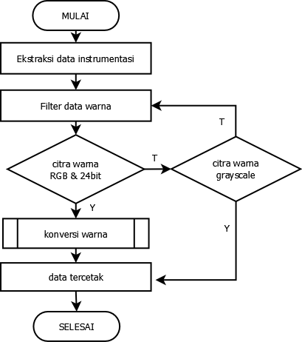

Figure 1. An example of using the Dia Diagram Editor software for making *flowcharts.*

The flowchart in the article is a cluster of images, so the occurrence of all charts related to the flowchart must be sorted by the occurrence of the image index. The images' presentation in the article uses the WRAPING TEXT -INLINE format . If the arrangement of images is more than one, you can use the help of a table with a no-border format. An example of presenting more than one image is shown in Figure 2, ac with a table's margin settings.

| IMG20170428154533  (a) | (b) | (c) |
| --- | --- | --- |

Figure 2. a) image description, b ) image description, c) image description.

*Source: editor's personal document – 10pt font*

An appeal to the author to be able to modify the shape, contrast, symbol or image pattern in considering image data information when there is a change from RGB to *grayscale*. The output of the JOURNAL OF IPTEK has two forms, namely digital script (publish web) and print. Referring to media *publishing*, the editor provides opportunities for authors in the fields of art, design, and the same field of science, if **the resulting image cannot be converted into a grayscale format**, then it is allowed to use RGB images, provided that **the printed text of the proceedings remains in colour black-and-white**.

The use of graphic image media as a data visualization of research results must be realized in images in the *grayscale format*. Authors can use a variety of symbols, textures and line patterns. It should be noted that for *finite element* contour data , converting the image to grayscale must still represent the pattern of data information. Authors are encouraged to consider that the proceedings are printed in black and white ink. The design of data plot drawings can be done using standard plotting software, for example, OriginLab ( *buy* ), Tecplot ( *buy* ), Sigmaplot ( *buy* ), Scidavis ( *free* ) and Magigplot ( *free* ). Figure 3 is the result of a data plot graph drawn using scidavis software. The editors do not recommend using ms. excel-based graphic support tool plots because they have a small resolution and low image vector patterns. The placement of graphic title is placed at the bottom as in the image naming.

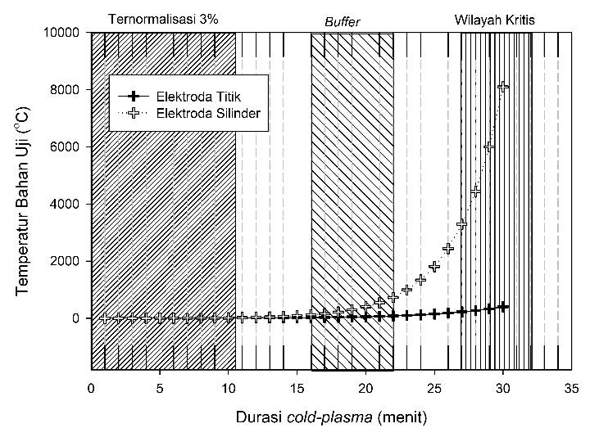

Figure 3. Correlation of X abscissa data to Y ordinate on M and N electrode variations.

**RESULTS AND DISCUSSION**

**Data Discussion I**

Writing the discussion can be composed of sub-discussions as in the following template. Data supporting the discussion can be in the form of graphs and tables. The table design in the manuscript has a format as in Table 1, namely the form of the table layout. Tables must be representative and easily understood by the reader. It is necessary to consider aspects of numeric data, variables and units to maintain the validity (validity) of the data. The author must consider a table with a lot of numeric data so that the table must be moved to another page so that the essential information is maintained. If the table that is written refers to a certain reference source, a **note can be given** at the bottom with the letters times new roman 10 pt ; *italic* .

Table 1. Layout data for JOURNAL OF IPTEK articles

| data to- | Variable A  (qualitative) | Variable B  (meters) | Result (unit) | | |
| --- | --- | --- | --- | --- | --- |
| I (unit) | II (unit | III (unit) |
| 1 | Safe | 300 – 400 |  |  |  |
| 2 | Currently | 300 – 400 |  |  |  |
| 3 | Danger | 300 – 400 |  |  |  |

*Note: Qualitatively refers to the 2011 BMKG index.*

**Data Discussion II**

The author must be careful in choosing the presentation of the data because the entire manuscript is only limited to a maximum of 8 pages. So it is necessary to select the correct data presentation using tables, graphs and discussion sentences. The format for writing mathematical equations or equations is like in the example equation (1). Mathematical equations are written with occurrence indices. The editors recommend using the *Microsoft Word equation feature*. This feature is found in all MS. Word products from the 2007 variant to the latest release [7] . Because the result of the Equation is a vector image that has a high resolution when compared to Insert | Equation. Equations written in the script must have an occurrence index. Make sure the author provides a description or information of some of the symbols used in the mathematical Equation. Efforts for text efficiency, the use of symbol descriptions can be included in paragraphs such as the following example statement "….. the value of the second term constant is expressed in ( ) and the next term is ( ) …..".

. …. (1)

**CONCLUSION**

This section contains conclusions from research results in numerical figures, qualitative policies or research model variables. The conclusion contains paragraph text and does not allow pictures, equations*,* and tables.

**THANK-YOU NOTE**

This section is optional and may be omitted by the author. The acknowledgement contains a preface of the author's appreciation for people, groups or institutions that contribute to the research program.

**BIBLIOGRAPHY**

[1] Center for History and New Media, “Zotero Quick Start Guide.” http://zotero.org/support/quick\_start\_guide.

[2] EJ Marmel, *Word 2016* . Indianapolis, IN: Visual, an imprint of Wiley, John Wiley & Sons, Inc, 2016.

[3] D. Graffox, “IEEE Citation Reference.” Sept. 2009, [Online]. Available: https://www.ieee.org/documents/ieeecitationref.pdf.

[4] M. Nur *et al.* , “Evaluation of Novel Integrated Dielectric Barrier Discharge Plasma as Ozone Generator,” *Bull. Chem. react. eng. catal.* , vol. 12, no. 1, p. 24, Apr. 2017, doi:10.9767/bcrec.12.1.605.24-31.

[5] PN Ministry, “Permendiknas No. 17 of 2010 concerning Prevention and Overcoming of Plagiarism in Higher Education,” 2010. http://idr.iain-antasari.ac.id/479/ (accessed Jun. 11, 2017).

[6] R. Macfarlane, *Original Copy: Plagiarism and Originality in Nineteenth-Century Literature* , 1 edition. Oxford; New York: Oxford University Press, 2007.

[7] D. Gookin, *Word 2016 for professionals for dummies* . Hoboken, NJ: John Wiley & Sons, 2016.